LED work lamps from WESEM not only for vehicles WESEM's LED and CRC3 lamp categories improve snow cannon performance
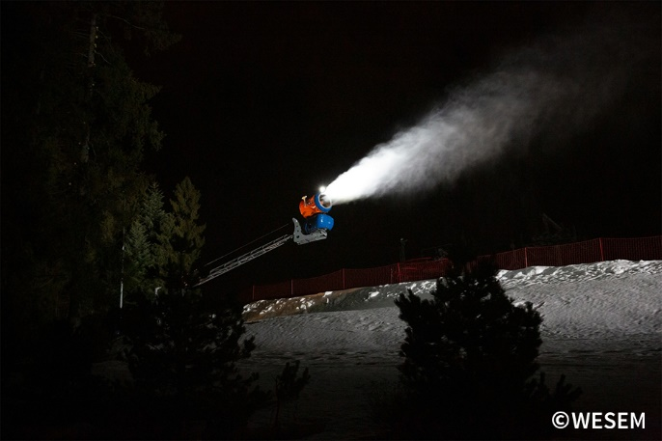
LED work lamps are mounted not only on vehicles but also on equipment operating at night. Such equipment includes snow cannons, which are often operated when it gets dark, after skiers leave pistes.
Users are steadily replacing halogen lamps used so far on snow cannons with LED lamps. Items of equipment with 12 V-24 V or 12 V-48 V power supplies are well-suited for WESEM's LED lamps intended for illuminating working areas for the equipment being operated. The advantages of LED lamps vs halogen lamps are common knowledge. Let us have a look at the advantages that are particularly relevant when it comes to choosing lamps for snow cannons; these strengths include:
- low power consumption (a LED lamp producing the highest luminous flux draws only 30 W),
- more light is produced at lower power consumption (a lamp producing a luminous flux of 1500 lm will provide much better light output than a halogen one, and will only draw 20 W),
- no need to replace bulbs and consequently no downtime,
- long service life of the product,
- suitability for use in adverse conditions.

Features and characteristics that are specific to WESEM's LED lamps and contribute to their robustness and durability in the afore-mentioned work environment include:
- solid design - resistant to vibrations,
- high IP rating (IP67, IP69K)
- suitability for service at low temperatures (starting from -40⁰).

When they need lamps for use on equipment, customers most often choose LED square-shaped lamps with a wide light beam that feature timeless design and excellent quality of execution.
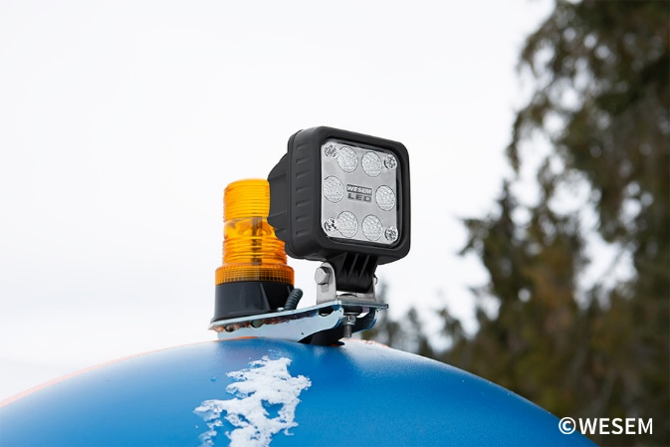
Still, customers' expectations are also well met by CRC3 work lamps, which have excellent technical characteristics and feature an option to choose various lamp shapes. The lamps are easy to mount or to replace, and do their job perfectly.
Recommended products for snow cannon manufacturers and distributors include: 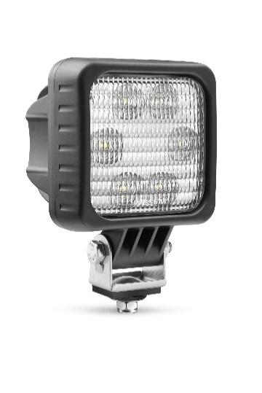 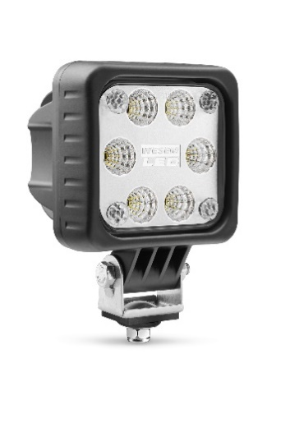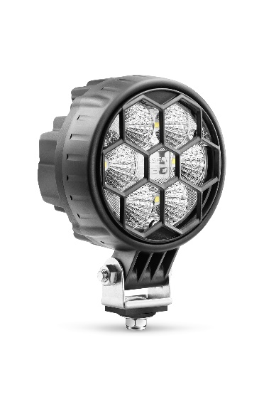
LED work lamp serie LED-FF work lamp serie CRC3 work lamp serie

As the skiing season has come to an end, now is the perfect time to upgrade, service, sell and install snow cannons with professional lighting which will ensure skiing enjoyment during the next season. WESEM’S lamps are available from lighting distributors across Europe.
Press release: WESEM
---
WESEM is a Polish manufacturer of lighting for cars, agricultural vehicles and slow moving machines.
Products designed and manufactured in Poland combine modern design with the latest technical solutions. Understanding of customers' needs, own design studio, laboratory and production plants allow to keep high standard of the goods. Products are available on European, Asian and American markets for many years.

