Compact LED work lamps for small and large tasks – CRK1 and CRC4 with a shallow heat sink

CRK1 and CRC4 with a shallow heat sink are the smallest lamps in WESEM's work lamp range in terms of size. The CRK1 and CRC4 product family, performing a work lamp function, has been extended to include two new lamps. Square- and round-shaped small-sized lamps with the same technical characteristics are now available.

The two new WESEM lamps:
- are energy-saving - consume only 12W,
- are compact – have the following dimensions: 68x68x49, Ø66x49, respectively,
- emit a wide beam – the beam angle is 43° x 34°,
- are waterproof – have the highest protection rating - IP67, IP69K,
- are durable and robust – are made from high quality materials and come with the Polish manufacturer's warranty,
- are resistant to shocks and vibrations – can be fitted on small low-speed vehicles that are operated in difficult conditions.

The CRK1 and CRC4 lamps are suitable for installation in small recesses, as additional light sources under vehicle stairs, on small vehicles used off public roads, and in cargo space in delivery vehicles and vans.

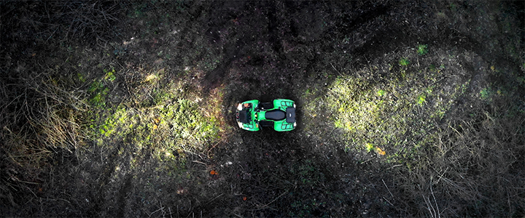

Product codes:
CRK1B.58000
CRC4C.57900

Press release: WESEM
---
WESEM is a Polish manufacturer of lighting for cars, agricultural vehicles and slow moving machines.
Products designed and manufactured in Poland combine modern design with the latest technical solutions. Understanding of customers' needs, own design studio, laboratory and production plants allow to keep high standard of the goods. Products are available on European, Asian and American markets for many years.

